**Active MQ Down troubleshoot procees**

**When the active mq webapp is not accessible via browser we have to follow these steps**

Step 1:- ssh into 10.228.159.205 (east bastian )

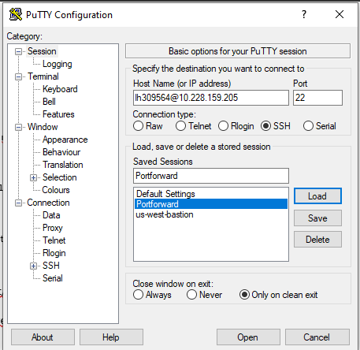

Step 2:- from east bastian **ssh** into **active mq ec2-instance** (ssh 10.228.145.117)

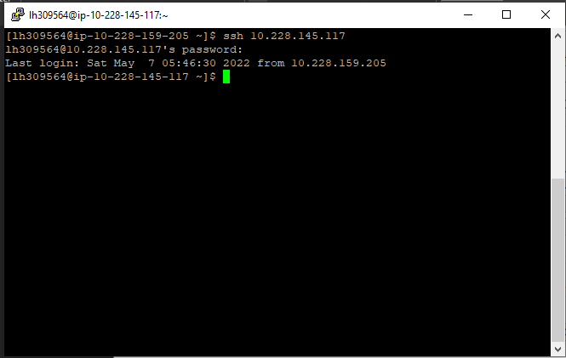

Step 3:- sudo su (root user)

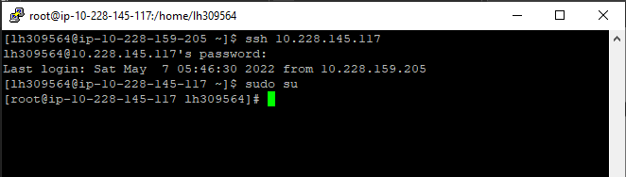

Step 4:- cd /mnt/apache-activemq-5.14.0/bin (this is the root folder for activemq application )

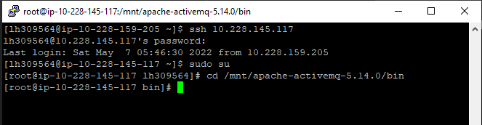

Step 5:- ./activemq start (this command will start the service of active mq)

